WASTE WISE PLAN TEMPLATE
Remember a good event waste management plan is a Waste Wise Plan. If you have an event waste management plan check to see if it includes the recommended elements in the template below. If you don’t have a waste management plan you can create one by completing this template.

[Event Name] Waste Wise Plan
[Event summary goes here]
Event Details
Event Name
Event Date/s
Event Time
Anticipated Crowd
Event Location

Waste Management
Type and volume of waste | Describe types of expected waste and use appendix X to estimate the volume of waste expected.
Event Bins | Use appendix 1 to calculate how many bins will be needed.  Note collection details such as who is providing and collecting bins. Also note who will be responsible for this.
Event Map | Map of where bins should be placed during event, use appendix 2 as a guide.  Note who will be responsible for the set-up of bin stations.
Waste education plan | Information about bin signage, bin monitors, as well as any additional waste education planned. (Information on page 6 and 8)
Single use plastics | Outline how you have replaced or avoided single use plastics at your event.
Relevant Policies | Purchasing and packaging policies, list and link to relevant policies.
Litter prevention | Outline of clean-up practices.

Waste Wise Checklist
Activity | Comments
Provide waste, recycling and organic waste collection bins. Numbers and placement of bins can be calculated and planned using the guidelines in Appendix 1.

If you rely on your stallholders, caterers, contractors, or staff to reduce waste then let them know before the event about Waste Wise events and your expectations from them. A template letter to let stall holders, caterers or contractors know about your Waste Wise event requests can be provided by Council.

All single use plastics are banned at events that occur on Council land. This includes:

- plastic straws
- plastic water bottles
- plastic plates, cups and drink stirrers/sticks
- plastic bags, cutlery and food packaging
- Polystyrene food and beverage packaging
- balloons
- plastic cling wrap
- merchandise or giveaways that you know won’t be used beyond the event.

Reward attendees for bringing their reusable cups, bags and bottles with discounts to encourage reusable items. For example, make coffees or meals 50c less in reusable cups/cutlery. If this is something you may need to ask of your stall holders, caterer, contractors or staff.

Consider how you can avoid food waste, try not to over cater, encourage participants to take home leftovers or even partner with an organisation or community group that collect leftover food and redistributes it to people in need.

Designate a staff member or volunteer to check for litter during the event and after the event.

Educate patrons, staff and other attendees about waste. Provide them with appropriate information, signage, and importantly – make it easy with good access to bins in the right places. Printable bin signage can be provided by Council (bins provided by council will have signage and stickers on them).

Reduce the need for plastic water bottles by providing access to tap water. Have a sufficient supply of freely available potable water for staff and patrons. For outdoor events portable ‘Hydration Stations’ are available for loan from the Strathbogie Events Team

Include the Strathbogie Waste Wise event logo on promotion and publicity materials. This is a public statement of commitment that your event will be Waste Wise.

Where possible, promote the use of aluminium cans over plastic and glass receptacles. Aluminium cans are lighter and less likely to break than glass, and can be repeatedly recycled.

Going Further.
This list is by no means exhaustive so feel free come up with some ideas of your own and let us know what your event is doing to be Waste Wise.
- Purchase items that are made out of recycled material, are recyclable, reusable or have a guarantee they are made to last
- Avoid products with excessive packaging or buy in bulk (for example, swap single-serve packaged products with loose or bulk packaged items).
- Use ‘environmental theatre’ to engage patrons in appropriate waste behaviour.
- Support sharing goods and services (hiring or leasing), rather than buying.
- Provide staff with reusable bottles (or ask them to bring their own) and provide or sell reusable bottles or cups to your attendees for use across your event.
- Complete a waste audit during the event. This may mean a simple visual bin inspection to estimate how full each bin is and types of waste contained in each bin, or a more detailed bin
- audit where a small number of bins are sorted a procedure for sorting event waste can be found here.
- Use a brochure, letter, training/briefing session or a simple conversation to inform and educate stallholders or staff so that they feel empowered to encourage patrons to be waste wise also. Some good resources can be found at www.boomerangalliance.org.au
- Send a thank you letter to complying stallholders involved in the event stating the diversion rate/ amount of waste diverted from landfill at the event.

Appendix 1: Planning the number and placement of bins
In general, expect a minimum of one litre of waste per person per meal. However, this may vary depending on catering, alcohol availability, number of profile of attendees, venue size as well as the waste minimisation strategies utilised.
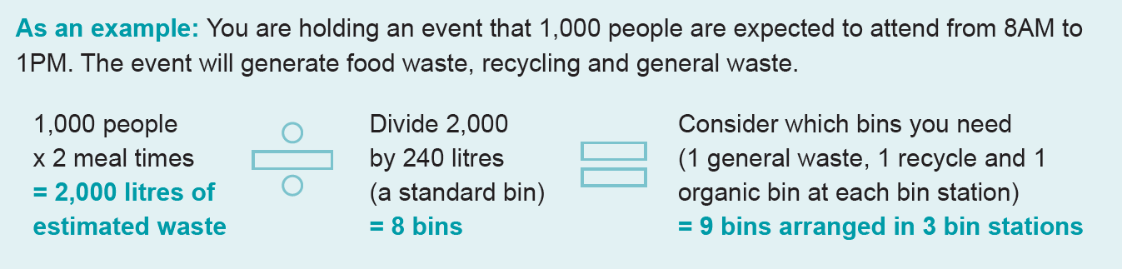
Bins should all be placed in a bin station, with each type available in a row, not back to back or apart. Bins should include information about what goes in each bin that is visible and understandable. This will allow patrons to easily see each of the bins available and choose the appropriate bin. Bin stations should be placed in accessible points that coincide with movement of people and catch their attention.

